COMPUTER SCIENCE FUNDAMENTALS AND CAREER PATHWAYS

Assignment 4

Topic: Design you career roadmap with smart goals.

Name: Dolare Shruti Manohar

Roll no: 2501730066

Cousre: Btech CSE (AI ML)

Section: C
STUDY PLANNER WITH TASK DESCRIPTION

Step 1:

Problem Defination:

Students struggle to manage their daily study tasks and often forget important deadlines.

So a study planner helps student :

- Add study tasks with deadline.
- View all tasks.
- Automatically check which tasks are due or overdue.
- Remind the students of upcoming task.

ALGORITHM:

1. START

2. Create an empty list called TASK_LIST

3. DISPLAY menu:
1. Add New Task
2. View All Tasks
3. Check Due Tasks
4. Exit

4. READ user choice

5. IF choice = 1 THEN
a. READ task_name
b. READ deadline_date
c. STORE task_name and deadline_date in TASK_LIST
d. DISPLAY “Task Added Successfully”
GO TO Step 3

6. ELSE IF choice = 2 THEN
a. DISPLAY all tasks in TASK_LIST
GO TO Step 3

7. ELSE IF choice = 3 THEN
a. READ today's_date
b. FOR each task in TASK_LIST:
i. IF deadline_date = today's_date THEN
DISPLAY “Task due today: ” task_name
ii. ELSE IF deadline_date < today's_date THEN
DISPLAY “Task overdue: ” task_name
iii. ELSE
DISPLAY “Upcoming task: ” task_name
GO TO Step 3

8. ELSE IF choice = 4 THEN
DISPLAY “Goodbye”
STOP

10. END
FLOWCHART:

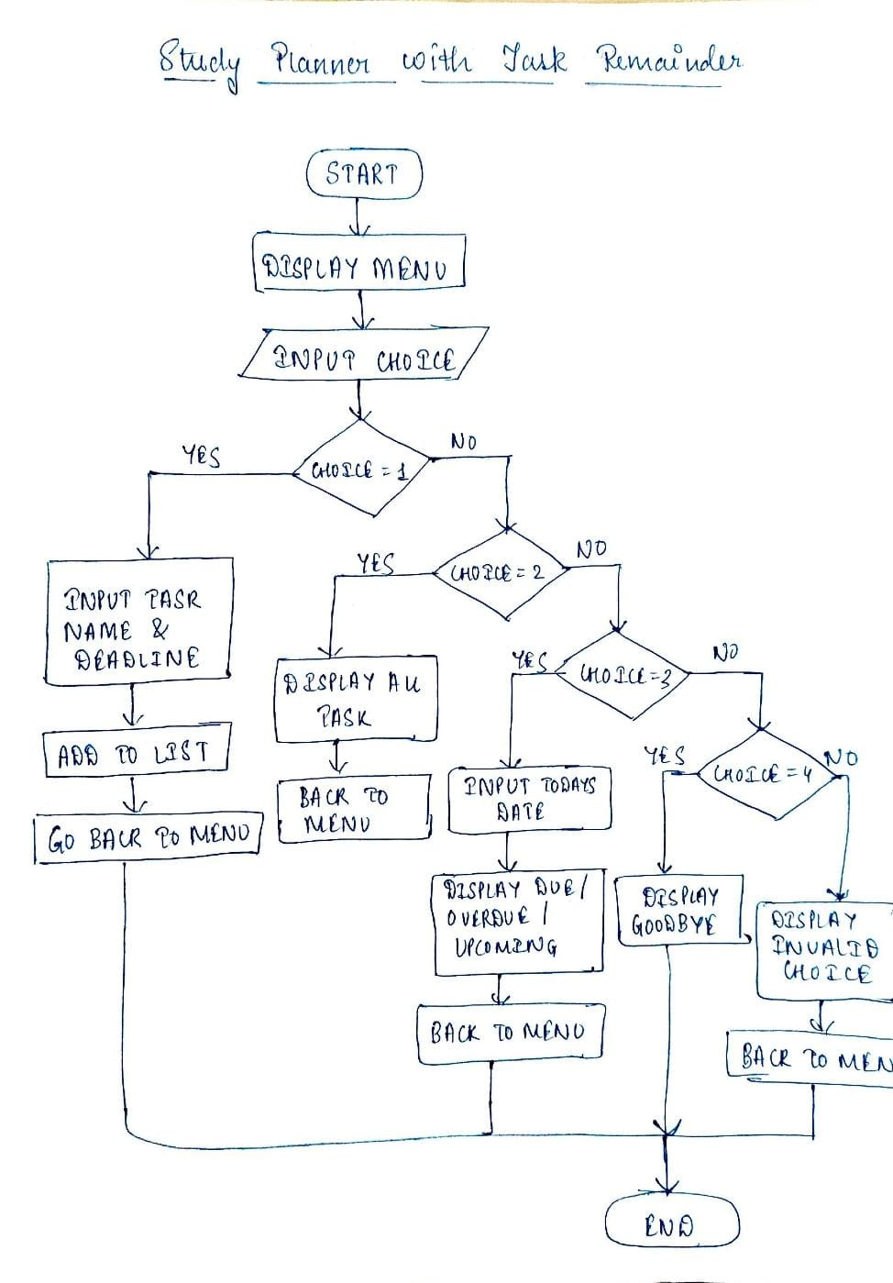
STEP 2:

# 10 Linux Commands (File management + Permissions):

- ls - list files

- ls-l - detailed list with permissions

- pwd- show current directory

- Mkdir study_folder- create folder

- cd study_folder- change directory

- touch notes.txt - create empty file

- cp notes.txt backup.txt - copy a file

- mv backup.txt old_backup.txt - rename/move a file

- chmod 744 notes.txt - change files permissions

- rm old_backup.txt - delete file

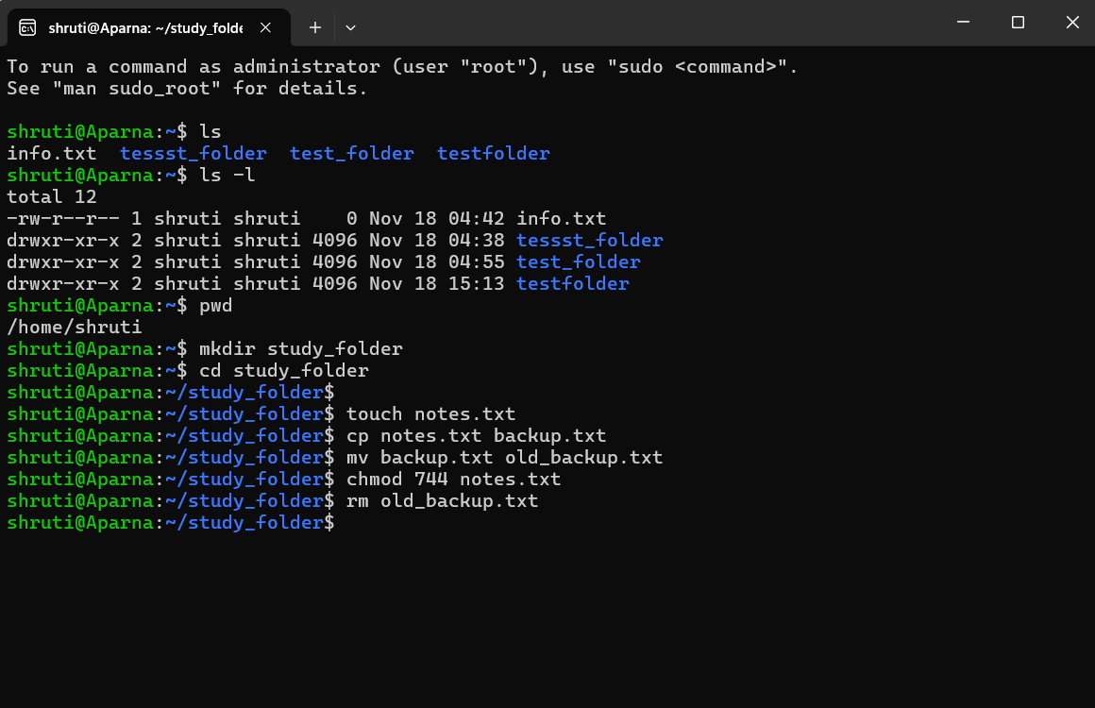

# BASH SCRIPT FOR AUTOMATION:

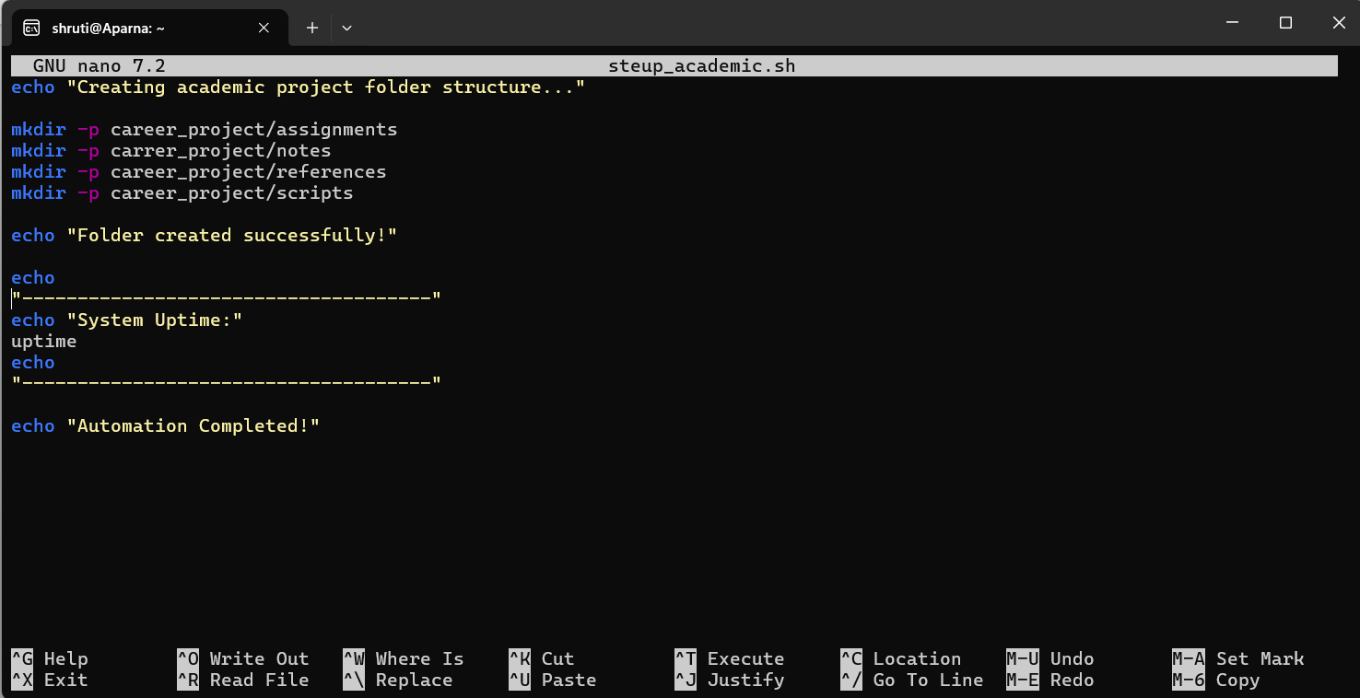
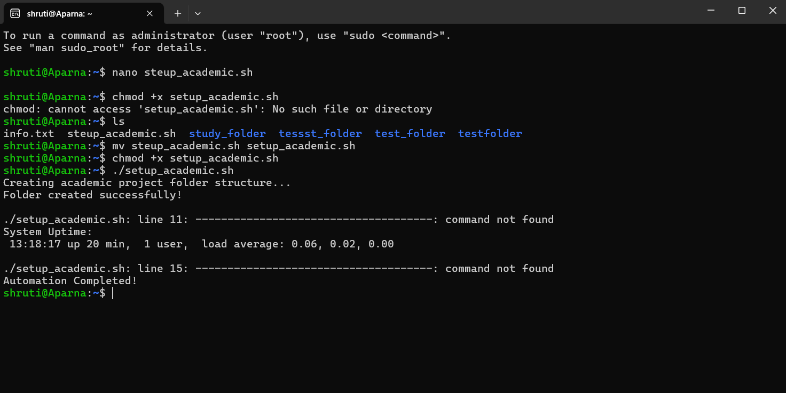

STEP 3: Exploring Emerging Technology Domain (CO3)

Artificial Intelligence:

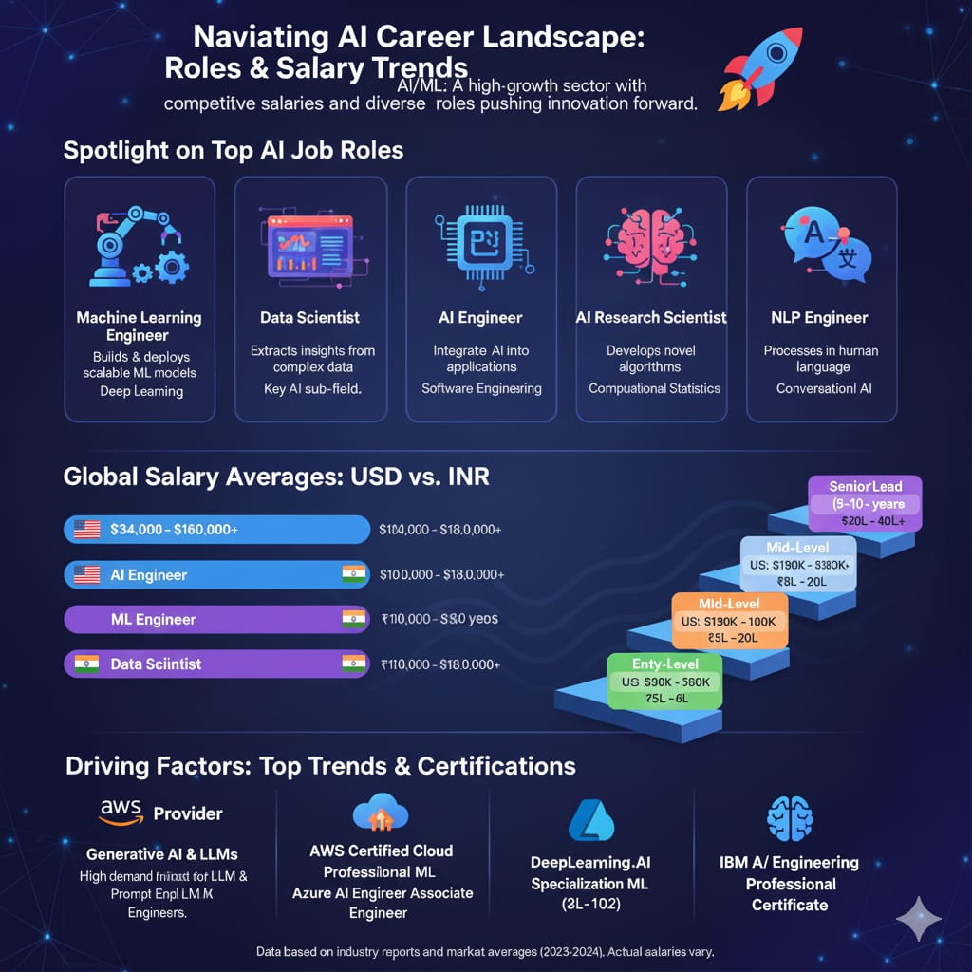
STEP 4:

# Smart Goals:

Short term goals (0-6 months):

- Complete a beginner-level AI certification.
- Finish an introductory AI course (Ex; google AI essentials).
- Earn the certificate and score at least 80% on assessments.

- 3-4 hrs study daily.
- Complete within 4 months.

Medium- Term Goals (6-18 months):

- Create projects such as image classification, sentiment analysis, and a mini chatbot.
- Upload 3 fully documented repositories.
- Using python, tenserflow, scikit-learn.
- Strengthens resume and internship opportunities.
- Finish within 12 months.

Long-term Goal (2-3 years):

- Get an AI-realted internship at a reputable tech comapany or startup.
- Apply to at lease 20 internship postings.
- With certifications + portfolio + linkedln optimization.
- Provides real-world AI experience for your future career.
- Secure internship by the end of 3rd year.

Certification 1: Google “AI Essentials”

Provider: Google

Duration: 10–20 hours (self-paced)

Cost: Approx ₹2,000–₹3,000

Skills Covered:

Fundamentals of Artificial Intelligence

Generative AI basics

Prompt engineering

Using AI tools (Google Gemini)

Ethics & responsible AI usage

Alignment With SMART Goals:
- Great for your short-term goal of learning AI basics quickly.
- Builds a strong foundation for your medium-term goal of creating AI projects.
- Adds credibility to your LinkedIn and resume as you grow in the AIML domain.

Certification 2: AWS Machine Learning – Specialty

Provider: Amazon Web Services (AWS)

Duration: 2–4 months (depending on study pace)

Cost: Approx ₹25,000

Skills Covered:
- Data engineering & preprocessing
- Machine learning model building
- Deep learning using AWS services
- Model deployment using Amazon SageMaker
- Real-world ML problem solving

Alignment With SMART Goals:
- Perfect for your medium-term goal (building professional AI/ML projects)
- Strongly supports your long-term goal of getting an AI internship
- Shows advanced knowledge in the AI domain, making you stand out among peers
- Highly valued by tech companies hiring ML engineers
# Linkedln Update:
Profile URL:
https://www.linkedin.com/in/shruti-dolare-4014b3382/
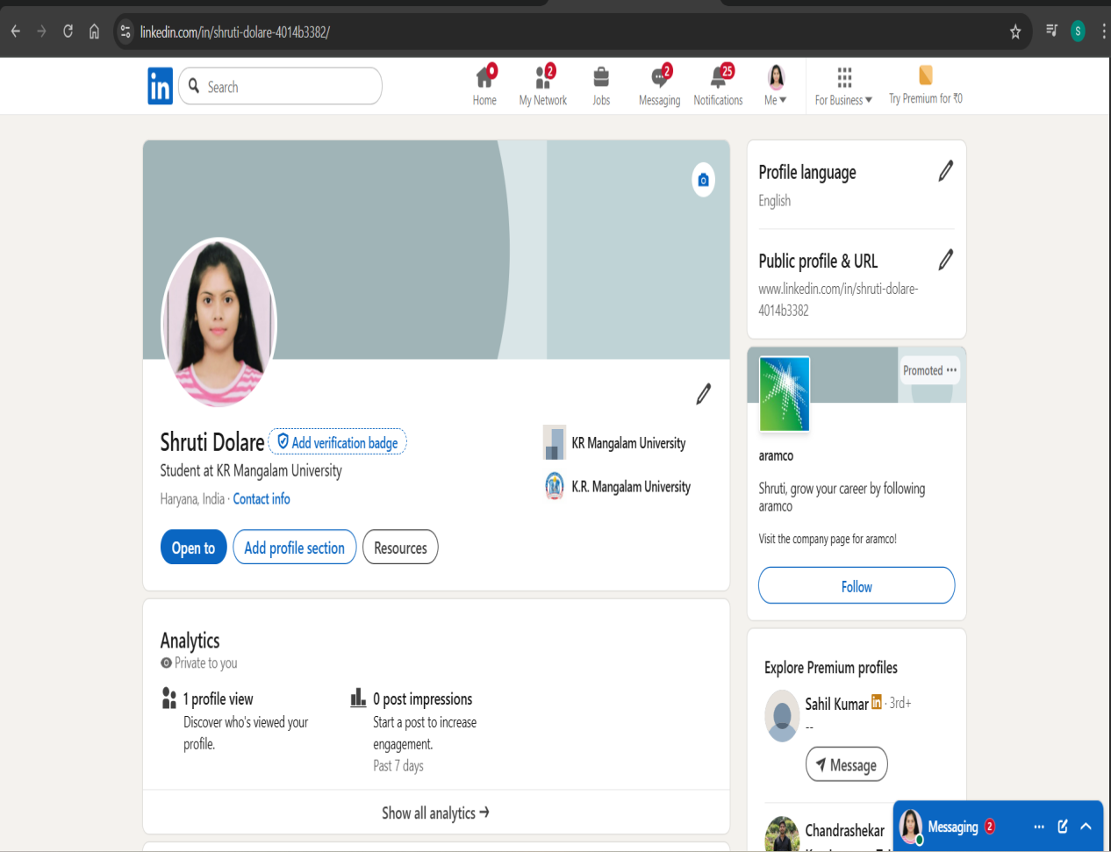

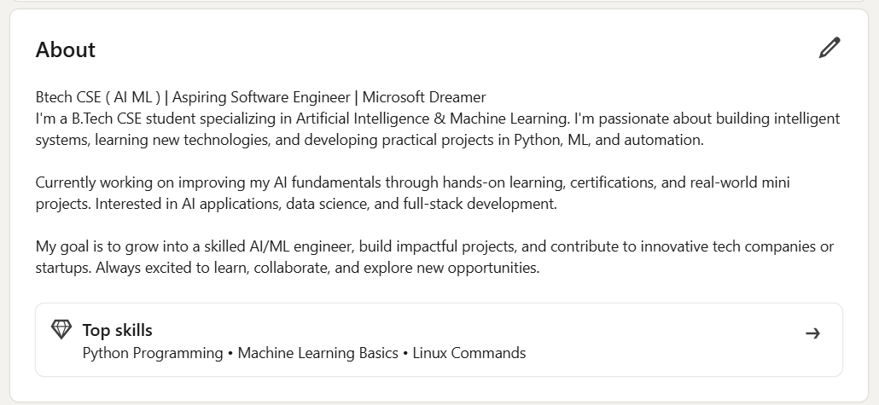

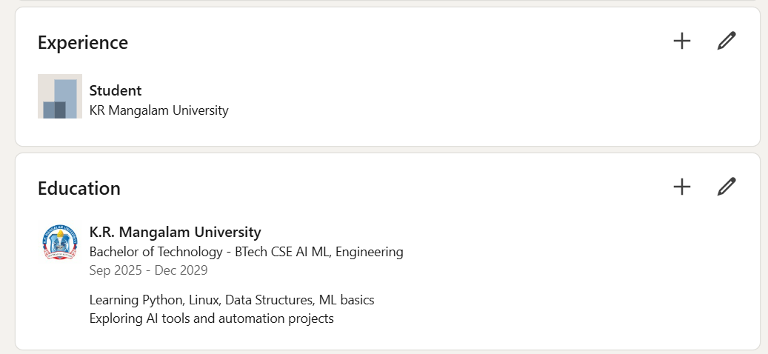

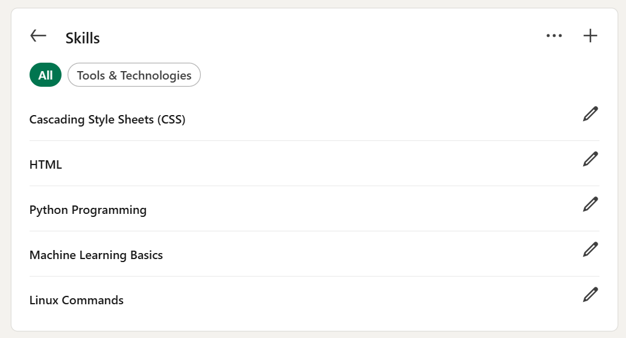
# CV:

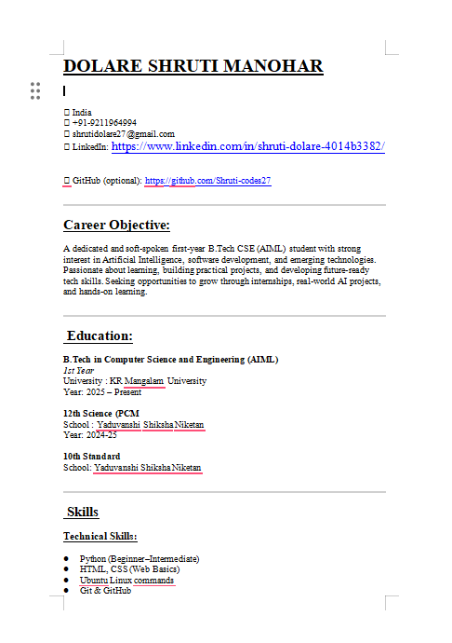
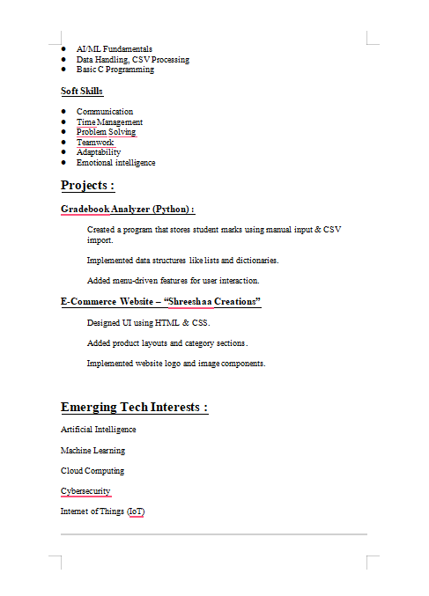
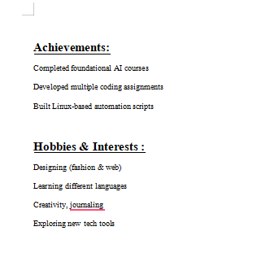
STEP 4: Hackathon/Contest/Open Source Plan

Event Name: Smart India Hackathon (SIH) 2026 – Software Edition

Organizer: Ministry of Education, Government of India

Mode: Hybrid (Online + Offline)

Planned Team Size: 4–6 Members

Why I Chose SIH 2026
It’s India’s biggest official hackathon
Focus on real-world problem solving using AI, ML, Automation, Cloud, IoT
Perfect match for my AIML specialization
Great for building portfolio, teamwork, and innovation skills
Highly valuable for internships and career opportunities.

Preparation Plan (Step-By-Step)

📌 Phase 1: Skill Preparation
Strengthen Python + ML basics
Learn Linux, GitHub, API usage
Practice coding on HackerRank / LeetCode
Complete AI/ML certifications
Review previous SIH problem statements

Phase 2: Team Formation & Idea Planning
Form a 4–6 member team
Select problem statements based on interest (AI, Healthcare, Education, Smart Automation)
Brainstorm ideas + choose one feasible solution
Start documenting features + tech stack

Phase 3: Prototype Development
Build basic working model (Python/ML/Cloud)
Create GitHub repo for the project
Run tests and improve performance
Prepare demo video + screenshots

Phase 4: Submission & Review
Create PPT + solution document
Upload solution on SIH portal
Prepare for internal college hackathon (prelims)

Phase 5: Final Preparation
Improve UI/UX
Add ML model optimization
Prepare pitch, demo flow, and presentation
STEP 5: Career Roadmap
Domain: Artificial Intelligence & Machine Learning (AIML)
Duration: 2025–2029
My long-term goal is to build a strong career in Artificial Intelligence & Machine Learning (AIML) and become skilled enough to work in the tech industry right after graduation. Since I do not plan to pursue post-graduation, my focus will be on gaining industry-ready skills, certifications, real projects, internships, and hackathon experience during my B.Tech itself.

1. Core Skill Development (Year 1–2)
The first milestone is developing strong fundamentals.
In Year 1, my target is to understand programming basics deeply — especially Python, C, and object-oriented programming concepts. Along with this, I will build my foundation in mathematics, statistics, linear algebra, and basic data structures. These skills are essential pillars for AIML.
By Year 2, I will start learning AI-specific skills such as Machine Learning basics, NumPy, Pandas, data preprocessing, data visualization, regression/classification algorithms, and problem-solving with small datasets. This period is also perfect for completing a few beginner projects like stock prediction, face detection, or recommendation systems.
I will also build a habit of using GitHub regularly so that every project becomes part of my portfolio.

2. Certifications & Hands-On Experience (Year 2–3)
Instead of post-graduation, I’ll focus on valuable certifications.
My plan includes:
Google Data Analytics / Google ML Crash Course
Coursera/IBM Machine Learning Specialization
DeepLearning.AI Short Courses
Microsoft Azure AI Fundamentals (AI-900)
During this phase, I will also start participating in hackathons, which help me test my skills under pressure, collaborate with teammates, and learn practical problem-solving. I will also contribute to small open-source projects, even if it's just correcting documentation or fixing easy issues — consistency matters.

3. Projects + Internship Preparation (Year 3)
By Year 3, I want to shift towards building real, impactful projects that can impress recruiters. This includes:
A complete ML project with deployment
A chatbot using NLP
A computer vision project
A mini research-style experiment
I’ll also start working on my resume, LinkedIn profile, and portfolio website.
During this time, I will prepare for internships through:
LeetCode basic questions
Company-wise interview patterns
Communication skills & interview confidence

4. Internships & Pre-Placement (Year 4)
The biggest milestone before graduation is getting at least one internship in Year 3 or 4.
The final year will focus on:
Final year AI-based project
Applying for internships or part-time roles
Attending campus drives
Building a strong recommendation network
Since I’m not doing post-graduation, getting experience + portfolio becomes my main pathway to enter the industry confidently.
STEP 5: Reflection Section
This assignment helped me understand my career direction more clearly and taught me how to plan professionally. I faced challenges in organizing everything and creating my CV and LinkedIn profile, but it improved my writing, planning, and technical skills. I also learned how to set realistic goals and explore opportunities like certifications and hackathons. Overall, this work made me more confident about my future in the AI field.

GITHUB REPO LINK:
https://github.com/Shruti-codes27/CSFCP-Assignment/tree/80e3200177c2ab882e2dee403888627af228c6ea/Lab%205(Capstone%20Project)

GITHUB LINK:
https://github.com/Shruti-codes27

